Cloud Architect

Compute

Lab Details

1. This lab walks you through the steps to create and configure a Stickiness in the Application load balancer's target group.
2. You will practice using Amazon Machine Image (AMI) to launch Amazon EC2 Instances, then create a target group and add these instances as a target. You will also create a load balancer and test the stickiness after enabling it by modifying the target group.
3. Duration: **90 minutes**
4. **AWS Region: US East (N. Virginia) us-east-1**

**Introduction**

What is Elastic Load Balancing?

* ELB is a service that automatically distributes incoming application traffic and scale resources to meet traffic demands.
* ELB helps in adjusting capacity according to incoming application and network traffic.
* ELB can be enabled within a single availability zone or across multiple availability zones to maintain consistent application performance.
* ELB offers features like:
* Detection of unhealthy EC2 instances.
* Spreading EC2 instances across healthy channels only.
* Centralized management of SSL certificates.
* Optional public key authentication.
* Support for both IPv4 and IPv6.
* ELB accepts incoming traffic from clients and routes requests to its registered targets.
* When an unhealthy target or instance is detected, ELB stops routing traffic to it and resumes only when the instance is healthy again.
* ELB monitors the health of its registered targets and ensures that the traffic is routed only to healthy instances.
* ELB's are configured to accept incoming traffic by specifying one or more **listeners**. A listener is a process that checks for connection requests.

**Architecture Diagram  
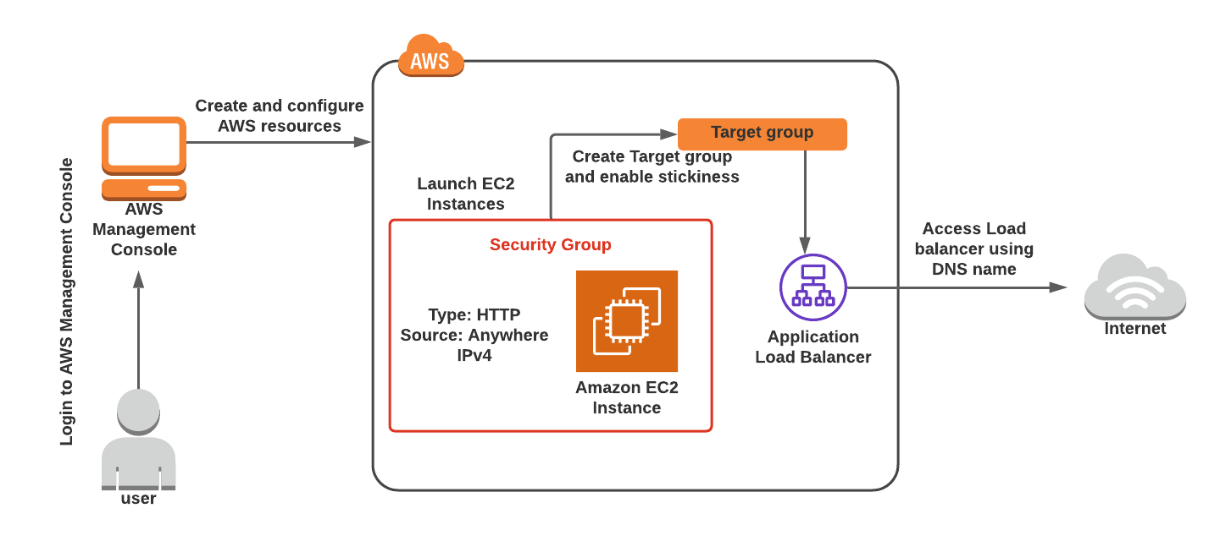**

Task Details

1. Sign in to the AWS management console
2. Create a Security Group for the load balancer and EC2 Instance
3. Launch EC2 Instances a Security Group for Launch template
4. Create target group and application load balancer
5. Enable stickiness by modifying the Target Group attribute
6. Testing the stickiness
7. Delete AWS Resources

**Launching Lab Environment**

1. To launch the lab environment, Click on the  button.
2. Please wait until the cloud environment is provisioned. It will take less than a minute to provision.
3. Once the Lab is started, you will be provided with **IAM user name**, **Password**, **Access** **Key**, and **Secret** **Access** **Key**.

**Note** : You can only start one lab at any given time